Pikesville Middle School
Supply List
2019 - 2020

GENERAL SUPPLIES:
- Two 2-inch binders: One binder for A days and one binder for B days.
It is recommended that students get two different colored binders to help keep track of their A day binder and B day binder. Using two different colors is highly recommended to help students with organization. Students will only need to carry one binder to school each day – following the A and B day calendar.

School Hours: 8:00 a.m. – 2:30 p.m.
Doors Open: 7:50 a.m.
*Breakfast at 7:45 a.m.
School Phone: (410) 887-1207
Guidance: (410) 887-6725
Nurse: (410) 484-9347

- 8-tab dividers – Each binder should be divided into 4 sections
(Students will have 4 classes each day)
- Loose-leaf notebook paper
- #2 Pencils
- Pens (blue or black)
  - Red for World languages
- Highlighters
- Colored pencils or markers
- Post-it Notes
- USB Flash Drive for saving computer work
- Headphones or earbuds to use with computer devices
- Small drawstring backpack
- See example Students are not permitted to carry regular backpacks during the school day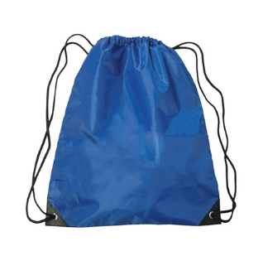

OTHER RECOMMENDED MATERIALS:
- One pocket folder w/prongs for each class
- One spiral notebook/composition book per class
- Computer mouse
- Graph Paper for math
- Ruler
Optional Math Calculators:
6th & 7th Grade – 4 function (TI – 108)
8th Grade – TI – 30XS
Algebra 1 & Geometry – TI 83 or higher
ART
Spiral-bound sketchbook with 8x10 or 9x12 white paper. These will be available for purchase from the students’ art teacher.

PHYSICAL EDUCATION
ALL students need a PE uniform. This uniform can be purchased for $20.00 from Pikesville Middle School during PE class the first week of school. Uniforms include a t-shirt and shorts – each individual piece of the uniform is $10. Payment for PE uniforms must be in the form of cash or money order made out to “Pikesville Middle School.” We are unable to accept personal checks.

DANCE
Students enrolled in Dance will need black attire as a part of their uniform. This includes black leggings, leotard, tank-top, short, and/or t-shirt.

- Refer to individual class syllabus for any additional materials that may be needed.
- Consider locker size when purchasing backpacks.
- Feel free to purchase anything additional that you think your child needs to be successful and organized. Example: Pencil case, agenda, individual sharpener, erasers, etc.
- Please consider donating any of the following supplies to your child’s classroom: pens, pencils, dry erase markers, tissues, post-its, gallon size Ziploc bags, hand sanitizer, glue sticks, and/or Lysol or baby wipes.

