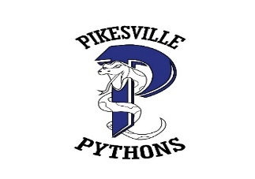
Pikesville Middle School’s Opening Information

(School Hours: 8:00 am-2:45 pm)

Introductory statement: We are excited to welcome students back to Pikesville Middle for face-to-face instruction for 5 days a week. We will continue to build community within our classrooms by practicing our social emotional learning strategies to engage ALL students. Use this site to find all resources related to COVID for Baltimore County Public Schools.

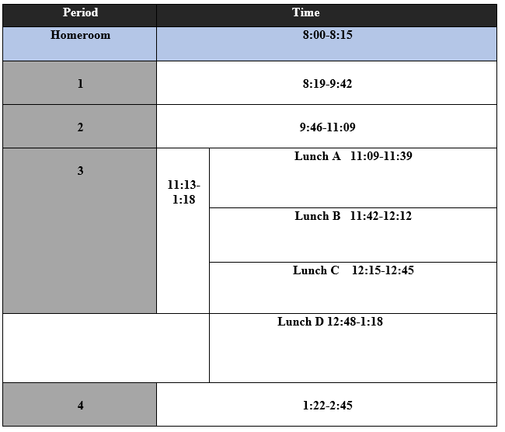

Arrival & Dismissal Procedures  Arrival:  - Students can enter the building at 7:45 a.m.​  - Students who do not want to eat breakfast, will enter through the appropriate grade level door.  - If students arrive prior to 7:45 a.m. all social distancing protocols must be met, while outside (6 ft apart, masks on, no touching)​  Dismissal:  - Walkers and car riders will be dismissed at 2:45 p.m.​  - Bus riders will dismiss in the order their bus is called. If their bus is not called prior to 3:00 p.m. they will line up outside or in the cafeteria.  - Students should immediately exit the building following the arrows when dismissed. | Screening & Testing (Safety is Our True North)  - All families should screen students for symptoms prior to leaving home.  - Please use this checklist to determine if a student should or should not go to school.  - Persons with COVID-19 symptoms in school will be required to be tested or will be placed on quarantine, in alignment with guidance from the Maryland Department of Health.
Face Covering (Safety is Our True North)  Requirements: All persons, regardless of vaccination status, must wear a face covering while inside a school. Exceptions to this requirement are:  - The person is alone in a private space.  - The person is eating or drinking.  - The person has a documented physical or developmental disability that makes wearing a mask unsafe.  - The person is under the age of two.  The person is a student athlete engaged in the sport in the field of play. | Social Distancing (Safety is Our True North)  Requirements: Physical distancing of students from each other and between students and adults will be provided to the greatest extent possible, considering school enrollment and facility constraints. Strategies include:  - Use of classroom and cafeteria configurations that provide maximal separation between students.  - Plans for arrival, dismissal and change of classes to reduce gathering of students in any area.  - Restriction of field trips to day trips only, with plans to reduce exposure to large crowds.  - Plans for supervision of restrooms, locker rooms, and school lockers to prevent congregation of students.
Hand Hygiene (Safety is Our True North)  Requirements: Employees and students have been instructed to adhere to best practices in hand hygiene and respiratory etiquette.  Times for handwashing or use of hand sanitizer to include before and after meals, upon arrival to schools’ offices and home, before and after use of any shared items, after use of the restroom, after sneezing/coughing and other time hands are contaminated. | Breakfast & Lunch  Breakfast:  - Any student who would like to eat breakfast, will enter the main entrance, and go into the cafeteria. Students will grab their breakfast and head to homeroom. Students will eat breakfast in homeroom.  - Breakfast will be free for all students  Lunch:  - ALL students will eat in the cafeteria. ​  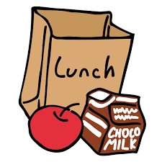  - Lunch will be free for all students.  ​
Supplies & Devices:  Lockers will be used this year. Students will report to their lockers twice during the day (before school and at the end of the day). Students must put their full size bookbag in their locker at the beginning of the day. Students are allowed to have a drawstring bag to carry during the school day.​  ​  What to Pack:​  - Computer/charger​  - Art supplies*, ELA, and History novels* if student has that class​  - Headphones ​  - Water bottle​  - Pencil/notebook​  - Lunch if student chooses ​  ​ | Visitors (Safety is Our True North)  - To visit a BCPS school, visitors must have an appointment.  - Visits will be conducted remotely or outside, whenever possible.  - If an indoor visit is required, visitors will be required to wear a face coverings and practice social distancing.  - The number of people admitted to the building will be limited.
Athletics (Secondary)/Extra Curriculars  - This site contains current information for mitigation related to athletics in BCPS.  - In October, we will begin having after school clubs. | Cleaning/Disinfecting (Safety is Our True North)  Requirements: BCPS staff will continue to provide safe and clean school environments by ensuring daily cleaning of buildings using Environmental Protection Agency (EPA) approved germicidal agents that kill coronavirus. BCPS staff will:  - Perform frequent cleaning and disinfection of high-contact surfaces and any shared items, at least daily.  - Promote hand washing before and after touch of shared use items.  - Maintain sufficient supplies of soap, paper towels, and hand sanitizer.

